COURSE DESCRIPTIONS
SPRING 2018

ENG 4110: Document Design
Dr. Sarah Beth Hopton

ENG 4172: Advanced Studies in Film – The Audiovisual Essay
Dr. Kyle Stevens

When we hear the word “essay” we often think of written prose, usually a personal expression of judgment or argument. However, as media platforms “pivot to video,” we are increasingly surrounded by audiovisual works that make points or encourage their “readers” to think about something in a new way. This course will introduce you to a history of films that might properly be called essays. It will also expose you to the recent trend in film criticism towards using this form in new ways. Moreover, it will provide you with the opportunity to make your own audiovisual essay.

ENG 4200: Editing
Dr. Rosemary Horowitz

Required text
Carolyn Rude, Technical Editing, Fifth edition, Allyn & Bacon, 2011.

Course description
ENG 4200. Editing (3). S. This course introduces you to selected concepts and methods of editing, basic editing skills, comprehensive editing processes and principles, and various management and production methods. Prerequisite: ENG 3090 or permission of instructor.

Course objectives
English 4200 will help you develop as an editor by introducing you to the principles and practices of the profession.

Course goals
After completing the course, you will be able to:
- describe the breadth and diversity of editorial responsibilities;
- discuss the various types of editing and levels of editing;
- exhibit skills basic and comprehensive editing;
- describe the various aspects of document management and production; and
- use various desktop publishing applications.

Course requirements
In this course, you will complete:
- a brochure project. In this project, you assume the roles of acquisitions editor, copy editor, or production editor. 100 points. Also, you will give an oral report with an accompanying style sheet. 100 points;
- a newsletter project. In this project, you work in groups to compile a newsletter for editors. Include at least 20 sources. 100 points;
- an electronic editing project. 100 points. Also, you will give an oral report with accompanying documentation on your work. 50 points;
- a variety of in-class assignments. 100 points; and
- participation. 50 points.

ENG 4509: Junior/Senior Honors Seminar
Dr. Germán Campos-Muñoz

Camelots: The Arthurian Legend in World Literature
ENG 4509, Junior/Senior Honors Seminar in World Literature

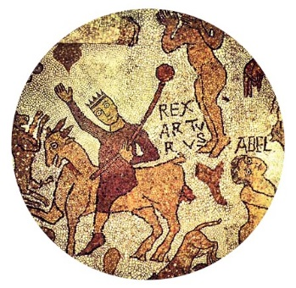

In its paradigmatic role as transcultural narrative, the Arthurian Legend vividly exemplifies the complex character of what we call “World Literature.” Firstly, it is worldly because the narrative of King Arthur aspires to operate as a full world in itself—with its own geography and seasons, its own social divisions and values, its own landscapes and edifices, and its own laws and languages. Secondly, it is worldly because, in spite of its best efforts, the Legend inevitably and distinctly reflects the world in which it is narrated—and thus becomes, at different times and in different places, an expression of cultural anxieties with respect to the Greco-Roman legacy, the pseudohistorical foundation of imperial projects, and the romanticized scenario of nostalgic counterpoints to an industrial and bourgeois style of life. Thirdly, it is worldly because it never remains fully localized: from its very first manifestations, the Arthurian Legend crosses cultural, linguistic, and representational borders with ease—from the Latin accounts of Medieval scholars to vernacular folklore in Welsh, Tuscan, Hebrew, Castilian, and Anglo-Norman, and from 6th-century monastic Scotland to 19th-century Victorian England, early 20th century modernist Japan, and mid-20th-century US pop culture.

Our course will interrogate the history of the perennial iterations of King Arthur and his Round Table in historiography, fiction, poetry, drama, performative and visual arts, films and videogames, across multiple linguistic traditions and periods. It will assess the importance of the Arthurian Legend in the formation of English history and identity, but will also foreground its perennial transgression of specific cultural borders, its constant reformulations, and the irresolvable tensions created among these multiple versions. In addition to weekly reading and audiovisual assignments, activities will include leading discussions, rhetorical contests, tests and written assignments, and a collective Arthurian narrative.

ENG 4550: Senior Seminar Creative Writing
Joseph Bathanti

Linked stories are also called short story cycles, short story sequences, composite novels, novel-in-stories and broken-novel. Essentially, these are series of stories in which the same characters appear, often in the same place, though the place can shift, stories that often share the same theme or preoccupations. The stories, in a linked collection, are designed and written to stand alone, and are not necessarily written in any kind of chronological or contiguous order. For example, a character might appear as an aimless high school student in Poughkeepsie and in another story as a married adult, working as a sous chef in Tempe Arizona. The binding agent of linked stories is usually a point of view character. Perhaps the most famous example of a contemporary collection of linked stories is Tim O’Brien’s The Things They Carried – which we’ll read during the course, as well as other texts featuring linked stories. Other contemporary examples of books of linked stories are Elizabeth Strout’s Olive Kitteridge, which won the 2009 Pulitzer Prize for Fiction; Denis Johnson’s Jesus’s Son; Rita Ciresi’s Sometimes I Dream in Italian; and so many more. A very early example of linked stories is Sherwood Anderson’s Winesburg, Ohio. As Junot Diaz, author of the linked story collection, Drown, says of linked stories: “It’s a neither-nor form I happen to like . . . when linked story collections work well they give the reader both the glorious ephemerality of the short story—its ability to capture what André Bazin called in a different context ‘contingency,’ the singular one-time event—and also some of the cooler aspects of the novel: its relational longue durée and its what-comes-next propulsion.” We’ll write three linked stories, one of which will be a flash piece, and workshop at least two of them and of course engage in lavish discussion and other related exercices. This is a Creative Writing capstone course.

ENG 4560: Adolescent Literature
Dr. Mark Vogel

Explores the exciting field of literature for and about adolescents. The course will trace the historical
development, noting pivotal books and authors, and investigating themes and issues surrounding adolescent
literature. The student will read at least 14 adolescent novels, and then link the texts to response-based teaching. Students will explore theories of adolescent development, read widely in adolescent literature, participate in web-based discussion, develop curriculum for teaching adolescent literature, and link adolescent literature with classictexts. If attempts to register online produce a Restriction, please contact me (vogelmw@appstate.edu) and I will let you in.

ENG 4560: Adolescent Literature
Dr. Elaine O’Quinn

Adolescents are among the most demanding readers of narrative. To them, story is everything. Understanding what makes Young Adult Literature successful helps answer the most elemental questions about storytelling. This course is designed to give prospective and practicing English teachers, as well as those generally interested in adolescent texts, a familiarity with the literature adolescents relate to, enjoy, and choose. We will analyze and come to understand what makes this literature simultaneously deep, fun, and meaningful,and examine the psychological and social constructions of adolescence and how such factors relate to literacy development. We will also consider critical issues related to identity and representation in young adult texts and explore questions such as: How do young adults understand identities related to race, class, gender, sexuality, culture, and nation? How are these identities represented in Young Adult Literature? What is missing for young adults in a traditional curriculum? To that end, exploring the history, genres, and literary hallmarks of adolescent literature will be central to the course. In addition, adult readers will develop a positive attitude toward Young Adult Literature and understand the consequences of resisting a literature intended for the important formative years of adolescence.

ENG 4580: Studies in African-American Literature
Dr. Carl Eby

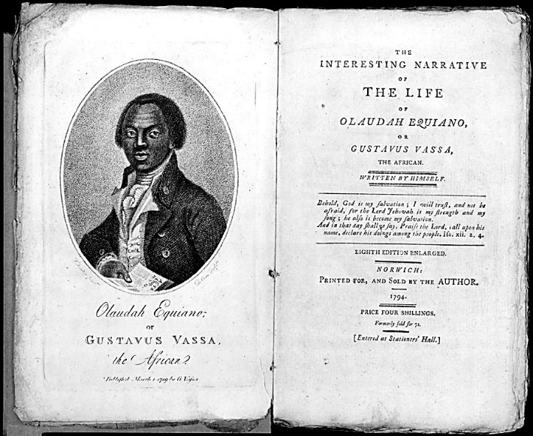
From Olaudah Equiano’s harrowing account of the middle passage to Toni Morrison’s Song of Solomon, this course will introduce students to some of the major writers, movements, and texts of more than two centuries’ worth of African American literature. We will explore how this tradition was forged out of the experience of diaspora, slavery, racism, and the struggle for civil rights, and we will explore how the unique experiences of African Americans shaped a distinctive literary tradition. We will investigate how African American writers created a literary tradition in dialogue both with each other and with (and within) surrounding literary traditions. We will try to identify the “masks” black writers have worn and the strategies they have employed in order to be heard by white America. And we will investigate the relation between the Harlem Renaissance and Modernism. As we explore the nature of race and the diversity of African American experience, we will pay particular attention to narratives of “passing” and to the role of social and economic class in African American literature.
Major texts will include The Norton Anthology of African American Literature (2-volume set: ISBN 978-0393911558); George Schuyler, Black No More (ISBN 978-1555530631); Zora Neale Hurston, Their Eyes Were Watching God (ISBN 978-0061120060); Ishmael Reed, Mumbo Jumbo (ISBN 978-0684824772); and Toni Morrison, Song of Solomon (ISBN 978-1400033423).

ENG 4590: Topics in World Literature
Dr. Chris Meade

ENG 4591: Theory and Practice in the Teaching of High School English
Dr. Leslie Cook

English 4590
Dr. Chris Meade

The grounds of analysis: Space and Place in World Literature
The term world literature implies some connection between the two objects of its study, literature and the world. Over the course of the centuries, though, the way in which that connection has been imagined has had several different forms that gave literature a different function in the world. Literature has narrated the creation of the world and explained to its readers what the world is; it has served as a reflection of the souls of nations, has mapped the exchange and contact between cultures in contact zones, and has created the marketplace within which global culture unified and homogenized itself. In this course we will study the literature of creation, migration, domestication, modernization and globalization in order to see how language and culture have played a key role in constructing the worlds humans have lived in.
Likely texts/authors include (not exhaustive)
Plato Timaeus
Genesis
Rig Veda
Popol Vuh

Amitav Ghosh
Christopher Columbus
Walt Whitman
Gloria Anzaldúa
..and more
ENG 4660: History of the English Language
Dr. Alison Gulley

This course examines English as a living and continually changing language. We’ll learn about English and its 1500-year history, with a focus on cultural, historical, and political influences on language evolution. We will also look at issues of language use, such as the notion of linguistic correctness, the construction of "standard" and "non-standard" English, spelling reform, the increasing hegemony of English on a world scale, and the important variations of English around the world and in the United States.
We will begin with the prehistory of English, including the Indo-European language family and where English fits into it. Then we will work chronologically, moving through Old English (before about 1100), Middle English (12th-15th centuries), and Modern English (16th century-present). Along the way, we will learn about historical events such as invasions, political and intellectual revolutions, immigration, emigration, and cultural assimilation as shaping forces in the living entity of the language.
Teaching and learning methods will consist of reading, writing, lecture, discussion, tests, and videos.

ENG 4730: The Novel
Dr. Zackary Vernon

The Novels of Faulkner and Morrison

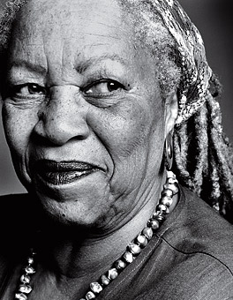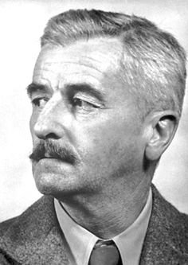

This course will examine the novels of two American Nobel Prize-winning authors, William Faulkner and Toni Morrison. We will explore their novels’ intertextuality, thus studying Faulkner through Morrison and Morrison through Faulkner. In particular, we will analyze the ways in which Faulkner and Morrison interrogate the lingering effects of slavery and racism within the South and the nation.

EENG 4770: Early American Literature
Dr. Colin Ramsey

ENG 4785: American Literature 1865 - 1914
Dr. Tammy Wahpeconiah

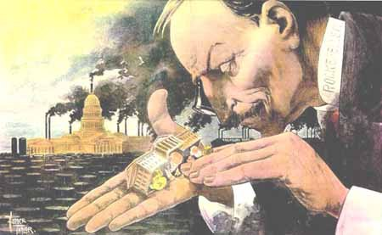
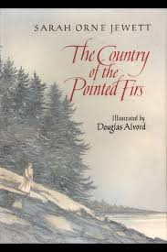
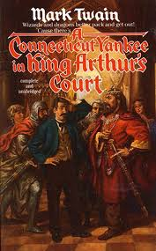
The post-Civil War period unleashed the social structures and tensions with which we grapple today. Mark Twain and Charles Dudley Warner’s 1873 novel The Gilded Age: A Tale of Today gave a name to the moment in US history during which, in their view, materialism, individualism, and corporatism came to define public life. Their title referred to a thin layer of gold covering baser metal, a metaphor for a veneer covering the ills of society. As Alan Trachtenberg has demonstrated, the Gilded Age forced Americans to question the meaning and purpose of the nation. This was the age of big business and class conflict; of mass urbanization and transportation; of race-based segregation and non-Anglo immigration; of globalization, imperialism, and the closing of the West. During this era, the power of money competed with the will of the people, and the wealth gap between the working and industrial classes widened. To respond to this crisis in the meaning of the nation, fiction writers turned to satire, realism, naturalism, regionalism, folklore, and science fiction to explore the changing landscape in the United States and the effects of a new economic reality on workers, families, immigrants, minorities, and women. This course will examine literature from this period to examine the cultural work of fiction to make sense of a changing society.

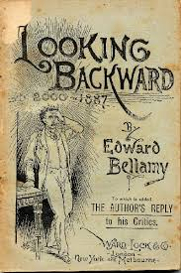
Texts: A Connecticut Yankee in King Arthur’s Court; The Country of the Pointed Firs; Little Women; House of Mirth; Maggie: A Girl of the Streets; Looking Backward; Life in the Iron Mills.

ENG 4795: Contemporary American Literature 1960 - Present
Dr. Mike Wilson
In this class, we’ll explore shorter American novels of the period between 1945 and 2014, with an emphasis on reading across a wide range of styles and thematic interests, within a similarly wide range of interpretive frameworks. Along the way, we'll also work on our analytical, reading, and writing skills. Past texts for my sections of this class have included seven or so selections from novels like William Maxwell’s So Long, See You Tomorrow, Richard Matheson’s I Am Legend, James Baldwin’s Giovanni's Room, Marilynn Robinson’s Housekeeping, Walker Percy’s The Moviegoer, Philip K. Dick’s Ubik, Ross MacDonald’s The Underground Man: A Lew Archer Novel, Shirley Jackson’s We Have Always Lived In The Castle, John Updike’s 1960 Rabbit, Run, Kurt Vonnegut’s 1963 Cat’s Cradle, Octavia E. Butler’s 1979 Kindred, Don DeLillo’s 1984 White Noise, and Jeffrey Eugenides’ 2002 Middlesex. Assignments and grading criteria usually include daily reading quizzes, midterm and final exams, and two papers.

ENG 4810: Advanced Folklore
Dr. Lynn Moss Sanders
ENG 4810/5710—Advanced Folklore Spring 2018 Dr. Lynn Moss Sanders

Advanced Folklore involves an in-depth and multi-cultural study of one or more folklore genres in cultural context with interdisciplinary approaches from the humanities and social sciences. In Spring 2018, the course will focus on folk Foodways. Readings will include a Southern Foodways Alliance publication Cornbread Nation 3: Foods of the Mountain South (2005, ed. Ronni Lundy) and A Mess of Greens: Southern Gender, Southern Food (2011) by UNC John Shelton Reed Distinguished Professor of Southern Studies, Elizabeth Engelhardt. A group project will focus on researching, developing, conducting, transcribing, and preparing an interview with Elizabeth Engelhardt to be submitted for possible publication in the Appalachian Journal.
The interview will be conducted on a field trip to UNC-Chapel Hill in conjunction with an Artist-in-Residence visit there by Ronni Lundy. Other readings will include literary texts that focus on Southern foods, such as Welty’s Losing Battles (a literary Jack Tale). Additional requirements include weekly reading response papers, and an individual foodways collection project and/or foods-in-literature project. ENG 3050 as a suggested pre-requisite is waived for this particular section of the course. Dual-listed courses require senior standing; juniors may enroll with permission of the department.

ENG 4840: Shakespeare – Later Works
Dr. David Orvis

This is a course on Shakespeare’s later plays, with particular emphasis on performance and adaptation. As we have no evidence Shakespeare ever intended any of his plays to be read as one would a book, it makes most sense to examine these dramatic texts as scripts or screenplays. Our aim, then, will be to ponder possibilities for performance in not only Shakespeare’s time but also our own. If fellow playwright Ben Jonson is correct in his assertion that Shakespeare “was not of an age, but for all time,” then plays such as Hamlet, Othello, and The Tempest will be shown to speak to, and also intervene in, contemporary conflicts and debates on a global scale. By semester’s end, students should be able to articulate such conflicts and debates as they find expression in a selection of Shakespeare’s later works. As well, they should come to understand and appreciate the radical emancipatory power of theater and theatrical performance as a whole.

ENG 4840: Shakespeare – Later Works
Dr. Susan Staub

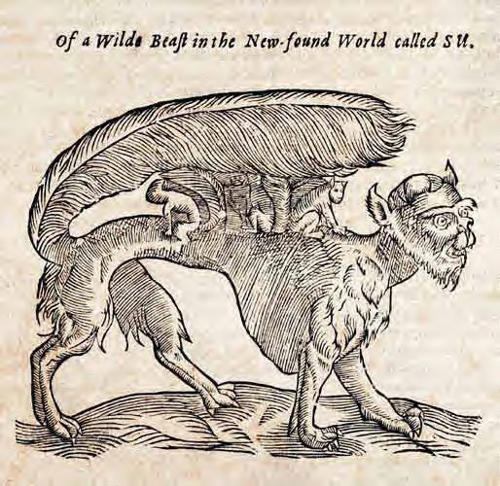
“Exit Pursued by a Bear”: Engaging Nature in Shakespeare’s Later Plays
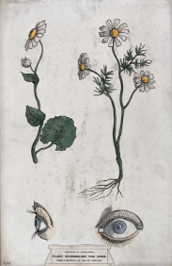
Shakespeare has always been praised as the poet of nature—a natural genius inspired by the non-human world around him and of which he seems to have intimate knowledge. His plays are filled with flora and fauna--with flowers, herbs, and weeds; with lions, and tigers, and bears (!); with maggots, flies, and worms. Blasted by storms, devoured by animals, defined by the ebb and flow of the Nile River, Shakespeare's characters are acutely aware of and connected to the natural world-- the natural cycles of life and death, the change of seasons and weather, the unnatural disruptions brought about by human intrusions. While Shakespeare frequently uses nature as a metaphor for turmoil in the social and political spheres, there is also a sense in which he speaks to our own understanding of ecology and of humankind’s responsibility to the environment. This course will consider a selection of Shakespeare’s plays (most likely, Hamlet, King Lear, The Tempest, The Winter’s Tale, Cymbeline, All’s Well That Ends Well, and Antony and Cleopatra) with an eye toward the non-human world and ecological moments in the plays.

ENG 4850: Renaissance Literature
Dr. David Orvis

Though his name has become synonymous with the Renaissance, and with Renaissance drama in particular, Shakespeare emerged from a bustling theatrical world that boasted numerous gifted dramatists writing for talented acting troupes. In this course, we will focus on the drama of Shakespeare’s contemporaries—playwrights who influenced and were influenced by him; who collaborated with him on scenes as well as entire plays; who competed with him for patrons, audiences, and cultural prestige; who derided his works even as they enlisted him to play major or minor roles in their productions. Situating these dramatists and their works in their cultural and historical contexts, we will trace the development of Renaissance drama from the establishment of first permanent playhouses in London in the 1570s and 1580s, through the construction and rise to prominence of the legendary Rose and Globe Theatres in 1587 and 1599 respectively, to the closing of the playhouses in 1642 by Puritans. We will read stage-plays by Thomas Kyd, Christopher Marlowe, John Webster, Ben Jonson, Thomas Middleton, Thomas Dekker, and Francis Beaumont as well as a closet drama by Elizabeth Cary. We will examine these plays as both cultural artifacts inextricable from their immediate contexts and scripts designed to be adapted to different places and times. This two-pronged approach will enable students to see why the Renaissance is often heralded as the Golden Age of Drama, and why this Golden Age lives on in the countless revivals and adaptations performed not just in London but in theaters around the world.

ENG 4860: Restoration and 18th Century Literature
Dr. Alex Pitofsky

A survey of British literature from the 1660s to the late 1700s. We will focus on genres (Restoration comedy, the novel, satire, poems in heroic couplets) and themes (marriage and the status of women, city life and the growing influence of the middle class, changing attitudes about criminal justice) that were especially prominent during the era. The concept of “periodization” will also play a key role in our discussions. Specifically, we’ll consider some of the labels – “Age of Reason,” “Augustan Age,” “Age of Enlightenment” – historians and critics have used to identify this era and ask whether they are useful or misleading labels for Restoration and eighteenth-century culture.

ENG 4895: 20th Century British Literature 1945 - Present
Dr. James Ivory

National and international cultural revolutions in gender, race, and class mark the second half of the 20th and early 21st centuries. This period known as postmodernity has lead to new ways to think about identity and nationalisms. Literature in this course will closely examine and follow postmodern ideas and examples of culture and history. This culture and history might be defined as post-imperialism, postmodernity, postcolonialism, and post-humanist and other emerging critical positions like ecofeminism. Post-imperialism explores cultural hegemony or how some writers “talk back” to diminishing powers of the British Empire. (Consider the Brexit vote as well as the failed but referendum on Scottish nationhood and independence in 2014 and after the Brexit vote). Many of these movements question their relationship to the British Empire and UK; a long history of indentured servitude or forced occupation tends to create feelings of discord. Even while some embrace some forms of Englishness, in the years noting the decline of Empire, writers often express ambivalence toward British history and its diminished role as a hegemonic power. Postmodernism examines narrative strategies and subject matter that interrogate the categories and practices of classical or canonical texts. Postcolonial writers often investigate and interrogate Britain’s imposed language, educational, and ideological systems. These writers emerge from a number of former colonies, like Kenya, Nigeria, India, the West Indies, and others, cf. the 2017 Nobel Laureate for Literature, Kazou Ishiguro (The Remains of the Day). The Post-human raises other difficult question about the “body” in terms of gender, queer, technologies, and ableism. The complexities in these writers’ fictions should lead to better understanding the importance of global communities, economies, and national diversity with a space often too overly “simplified” as postmodernity.

ENG 5520: Technical Writing
Dr. Olga Menagarishvili

Technical communication is a part of most careers and reaches a global audience. Because it helps readers get things done, you can think of technical communication as an “exchange of information” between you and your audience where, importantly, audience members may not share your particular knowledge base. Sets of instructions and documentation manuals are good examples: a reader does not need to know the intricacies of how a product works in order to assemble it and use it. It is your job, as the writer, to communicate information as clearly as possible by determining what is relevant to the task (purpose) and what is not.

In this course, you will study the conventions and theoretical underpinnings of technical writing and gain experience by creating documents representing a number of technical writing genres. These genres are tailored for you based on what you will likely encounter in your work life. This course will also introduce you to the process of writing and evaluating hypertext documents. Integrated in the course will be an emphasis on rhetorical principles, meaning writing is judged effective if it meets the needs of the audience, fulfills its communicative purpose, and is ethically appropriate.

ENG 5650: Gender Studies
Dr. Georgia Rhoades

In this course, we’ll read gender theory including landmark texts, invitational and material rhetorical theory as it relates to matters of gender, and literary criticism of the primary texts. The main focus of readings will be Irish and Irish/US novels and gender read in the political and religious contexts of that heritage, but we will also consider other genres and cultural artifacts. Primary literary texts will include selections from Horsley, Carey, O’Brien, Donoghue, Costello, McCafferty, Friel, Shaw, and Jones. Students will produce a portfolio of writing for a semester-long project culminating in a conference proposal and presentation. If you have questions about the course, please email me.

ENG 5710: Advanced Folklore
Dr. Lynn Moss Sanders

ENG 5760: Studies in American Literature
Dr. Bruce Dick

This course focuses on the 20th/ 21st century African American novel, as well as the evolution of African American critical thought over the last 110 years. We will begin with Charles Chesnutt’s The Marrow of Tradition (1903) and finish with The Underground Railroad (2016) by Colson Whitehead, but we’ll also discuss important 19th century African American novels as well as representative fiction by contemporary African American novelists. Other books for the course include Passing (Larsen, 1929); Their Eyes Were Watching God (Hurston, 1936); Native Son (Wright, 1940); Giovanni’s Room (Baldwin, 1956); Mumbo Jumbo (Reed, 1972); The Color Purple (Walker, 1982); Beloved (Morrison, 1988), and The White Boy Shuffle (1996). In addition, we’ll discuss a variety of supplemental critical essays from Angelyn Mitchell’s Within the Circle: An Anthology of African American Literary Criticism from the Harlem Renaissance to the Present (1994). Course requirements include class participation, reaction papers for all outside readings, and a 15-page, end-of-the-semester paper.

ENG 5810: Chaucer
Dr. Alison Gulley

This course will serve as an introduction to the works and cultural milieu of Geoffrey Chaucer, considered the greatest writer—and certainly the best known—in Middle English. Because this course is designed as a seminar, we will rely heavily on group discussion, although I will occasionally give brief introductory lectures and you and your peers will regularly present secondary Chaucerian scholarship to the class. Due to the difficulty of the language, there will be several activities to help you keep up, including memorization and translation exercises as well as a workshop on pronunciation. One assignment, the film review, will give you an opportunity to explore the Middle Ages in another context. Students will complete a term paper and class presentation (in conference format) on a topic of relevance to the matter of the course. You will also have the opportunity to participate in several activities with students and faculty in medieval studies across campus (In past semesters, activities have included films, medieval games, and a medieval cook-off). Students also have the opportunity to present their research at the Southeastern Medieval Association meeting which occurs during the fall semester after our class meets.

By the end of the semester, you should have
- in-depth, first-hand experience with Chaucer's works, particularly the Canterbury Tales.
- an overview of the cultural and political environment in which Chaucer lived and wrote.
- an acquaintance with the scholarly literature on Chaucer and his works.
- improved research methodological skills necessary for literary scholarship.
- the ability to participate in the discourse of medieval studies.
- further developed critical skills necessary for evaluating literary and scholarly work.
- a reading and speaking knowledge of one dialect of Middle English.

ENG 5870: Romantic Period
Dr. Bill Brewer

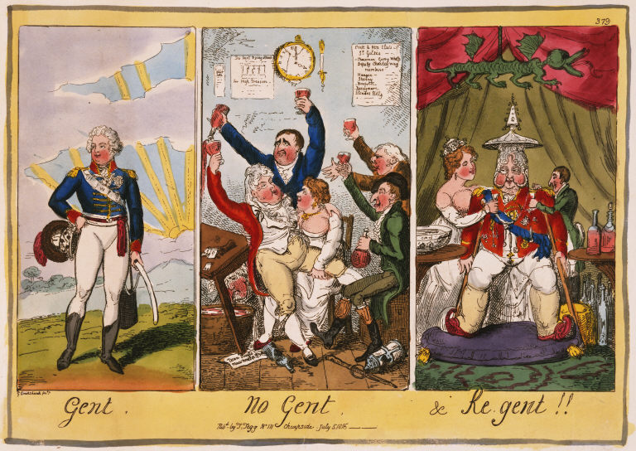
Course Description: Throughout 2018, British Romanticists will be celebrating the bicentennial of Mary Shelley’s Frankenstein, or the Modern Prometheus. In ENG 5870, Romantic Period, we will examine Frankenstein, Jane Austen’s posthumously-published novels Northanger Abbey and Persuasion (1817), and other important works written during the Regency Period (1811–1820). The Regency Period officially began when George Augustus Frederick, a compulsive gambler and heavy-drinking glutton, was appointed Prince Regent to his father, George III, who had succumbed to madness. During this time, war broke out between Great Britain and the United States; Napoleon invaded Russia, was defeated in the battle of Waterloo, and abdicated as emperor; Lord Byron published Cantos 1 and 2 of Childe Harold’s Pilgrimage (1812) and “awoke to find [himself] famous”; Byron proposed a ghost story writing contest that resulted in Frankenstein and John Polidori’s The Vampyre (1819); John Keats had his annus mirabilis; between ten and twenty English protesters demanding parliamentary reform were slain in the Peterloo massacre; and all of Austen’s six completed novels were published. Along with studying Regency Period novels and poems, we will immerse ourselves in the history, social practices, fashions, and culture of this tumultuous era.

ENG 5930: Transnational Literature
Dr. Çandar-Meade

Literature in Flight

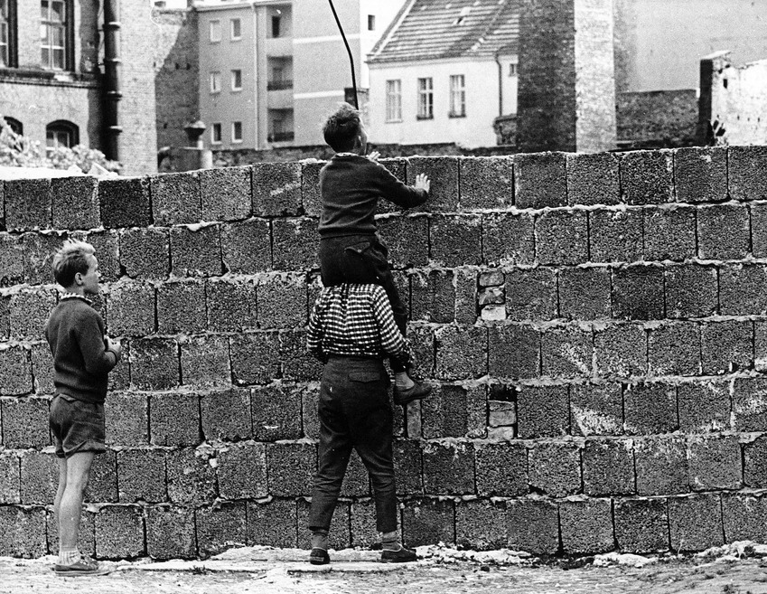

We all know there are national literatures. Most of us have also heard of World Literature and Comparative Literature. But what is “transnational” literature? (How) does it differ from national literatures and/or World Literature? Through a study of literary texts that complicate and transgress national and linguistic boundaries, in this course we will reflect upon and try to understand the notion of “transnational literature.” We will use the term “transnational” as a way of bridging the gap between the plural yet vague notion of World Literature, and the restrictive particularity of national literatures. We will think about the potentials and limits of transnational literature as a way of reading through difference.

To guide our discussions, we will be focusing on narratives of people/figures who muddle national frameworks: narratives of exiles, stateless peoples, refugees and (im)migrants.

Although the bulk of our readings will be novels, we will supplement these works with theoretical readings as well. Authors might include Junot Diaz, Gloria Anzaldúa, Arundhati Roy, J.M. Coetzee among others. Theoretical works might include texts by Hannah Arendt, Edward Said, Djelal Kadir and others.

